Power BI Assignment 2 – DAX & Data Visualization

Calculate column:
Created a Calculated Column called Category Type using category and sub-category.

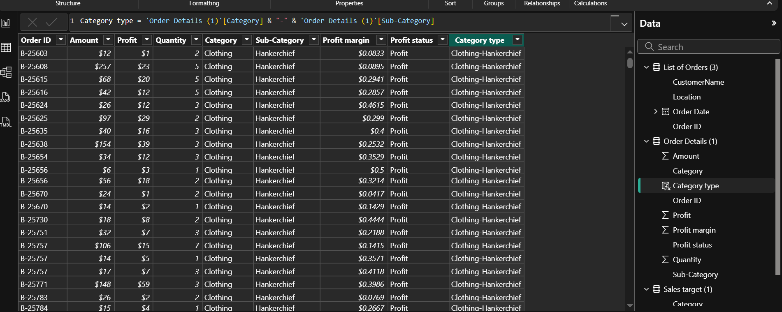

Formula used:
Category Type = 'Order Details'[Category] & " - " & 'Order Details'[Sub-Category]

Revenue per Order in Order Details :
Created a calculated column Revenue per order by using Amount * Quantity.

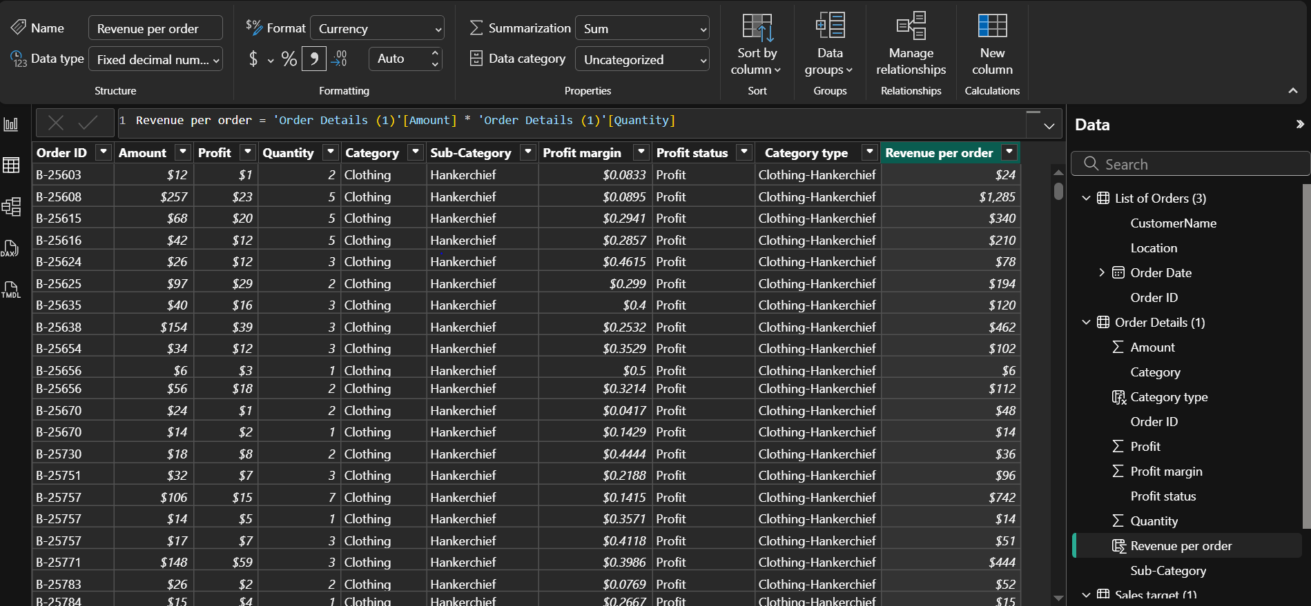

Formula used:
Revenue per Order = 'Order Details'[Amount] * 'Order Details'[Quantity]

Sales category:
Create a Calculated Column called Sales category using average average amount
as “Above average” and “Below Average”.
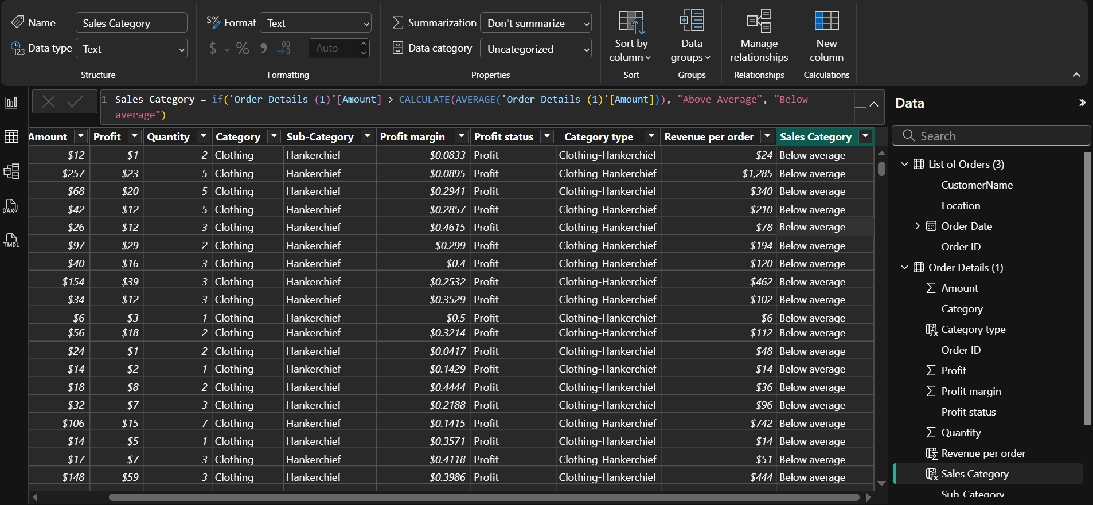

Formula used:
Sales Category = if ('Order Details (1)'[Amount] > CALCULATE (AVERAGE ('Order Details (1)'[Amount])), "Above Average", "Below average")

Calculated Measures:
- Order Count = COUNTROWS ('Order Details')

- Average Profit (Delhi) =CALCULATE (AVERAGE ('Order Details'[Profit]), ‘Order Details'[City] = "Delhi")

- YTD = TOTALYTD (SUM('Order Details (1)'[Amount]),'List of Orders (3)'[Order Date]. [Date])

DATA VISUALIZATION:

Sales Target Achievement by Category:
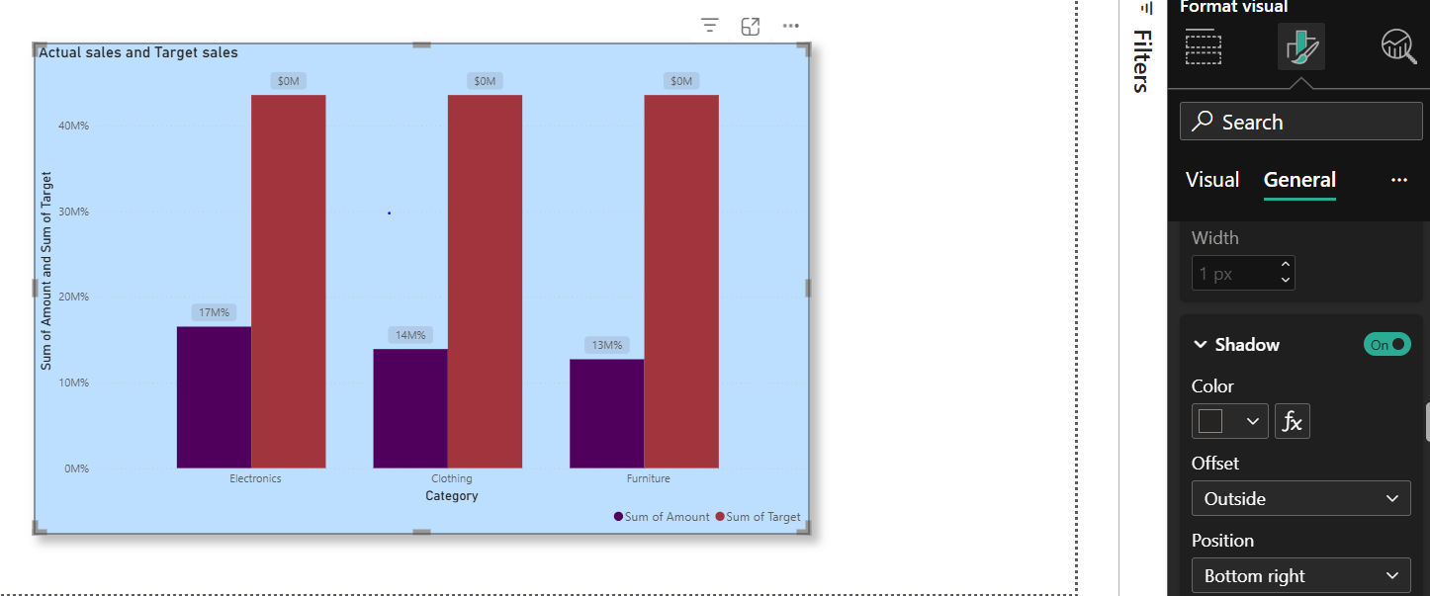

Max Profit Margin by Sub-Category:

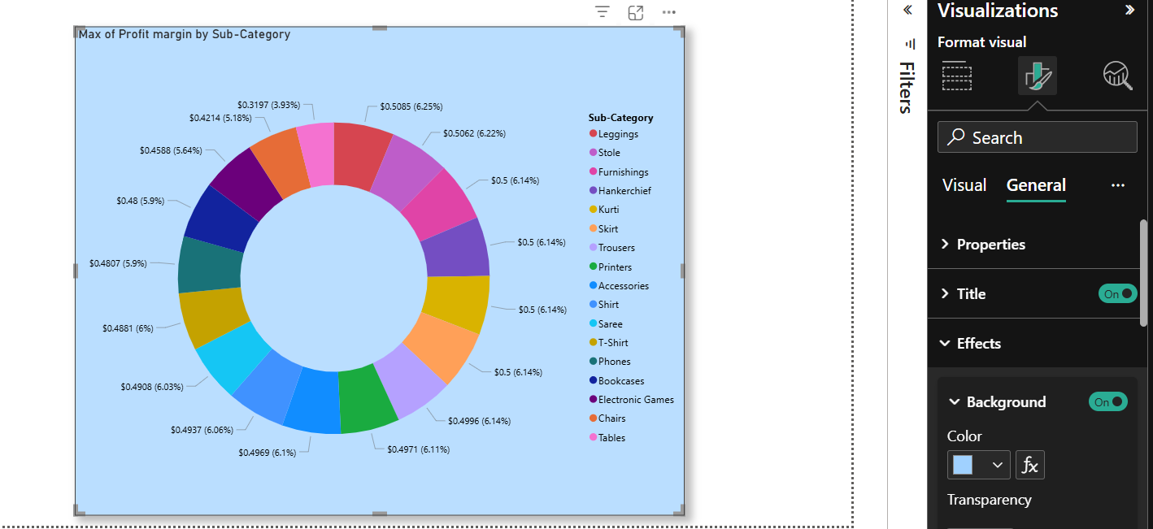
Monthly Sales Trend:

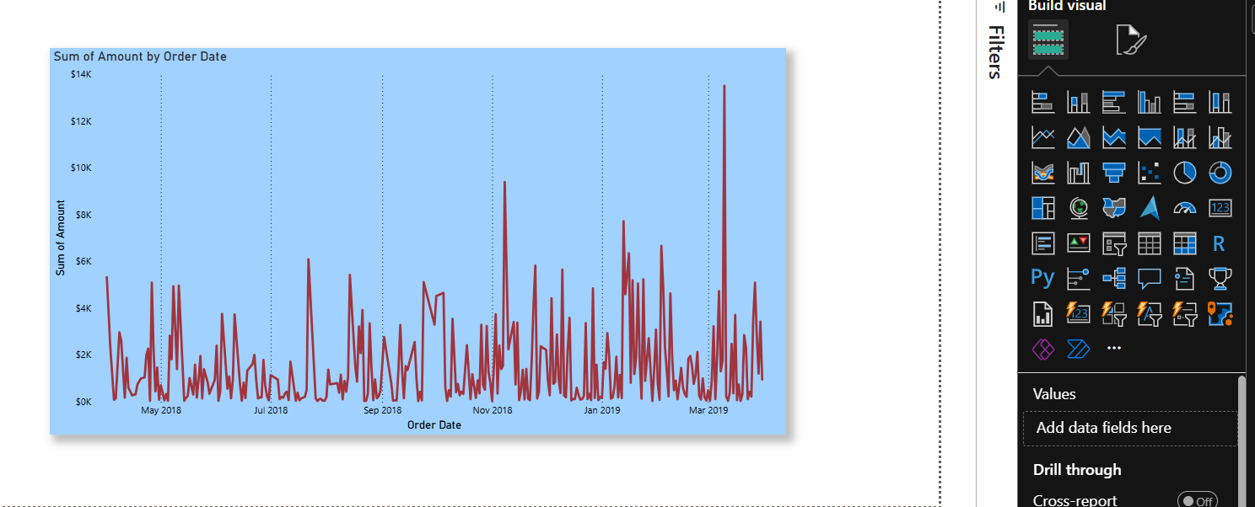

Comparison of Profit and Quantity by Sub-Category:
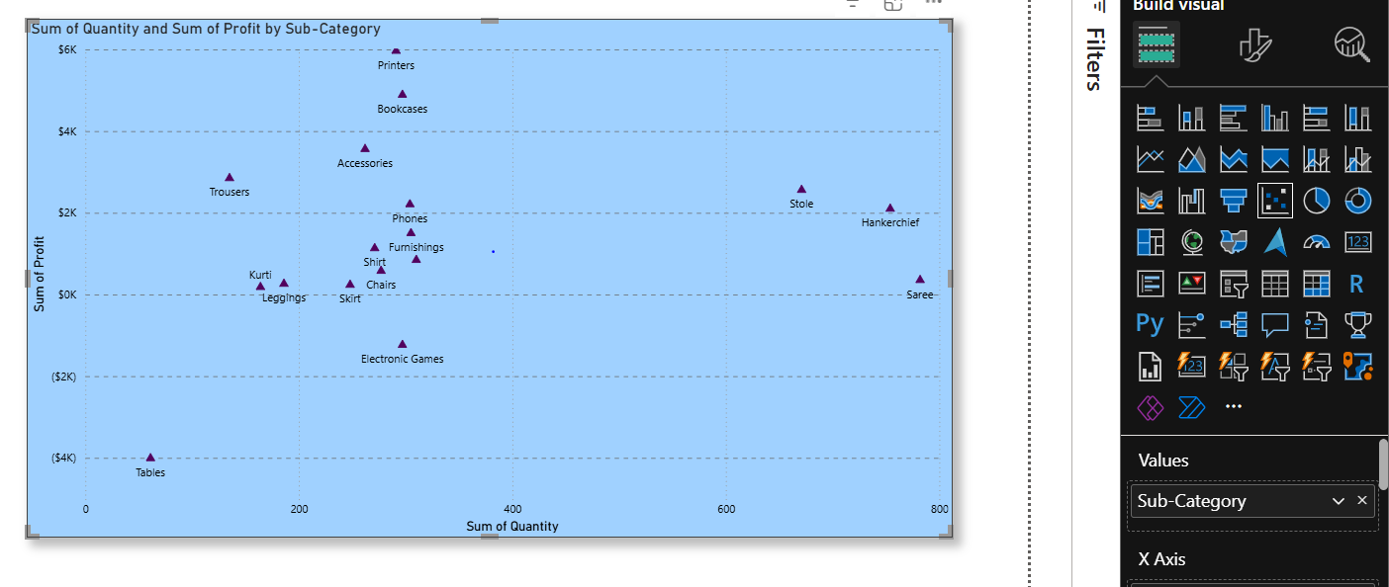

Comparison of Total Sales Amount and Target:

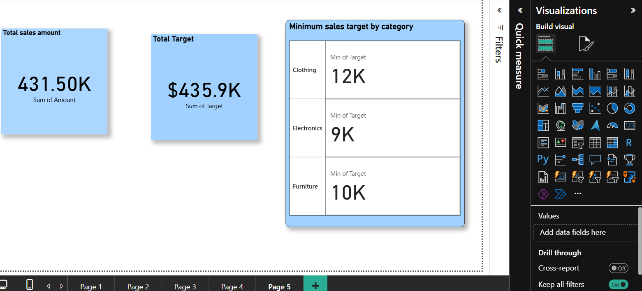
Sales Performance Matrix:
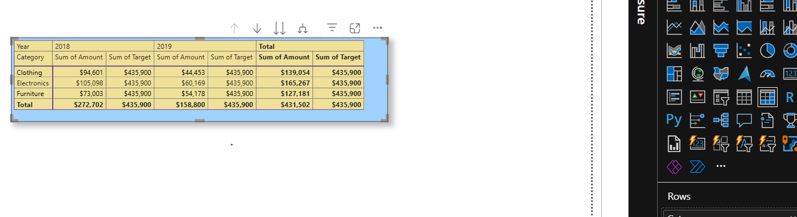
Geographic Sales Analysis:
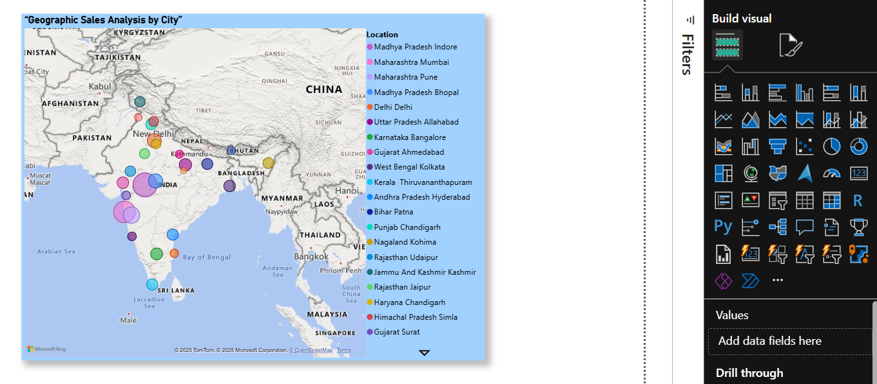

Sales Distribution by Sub-Category:

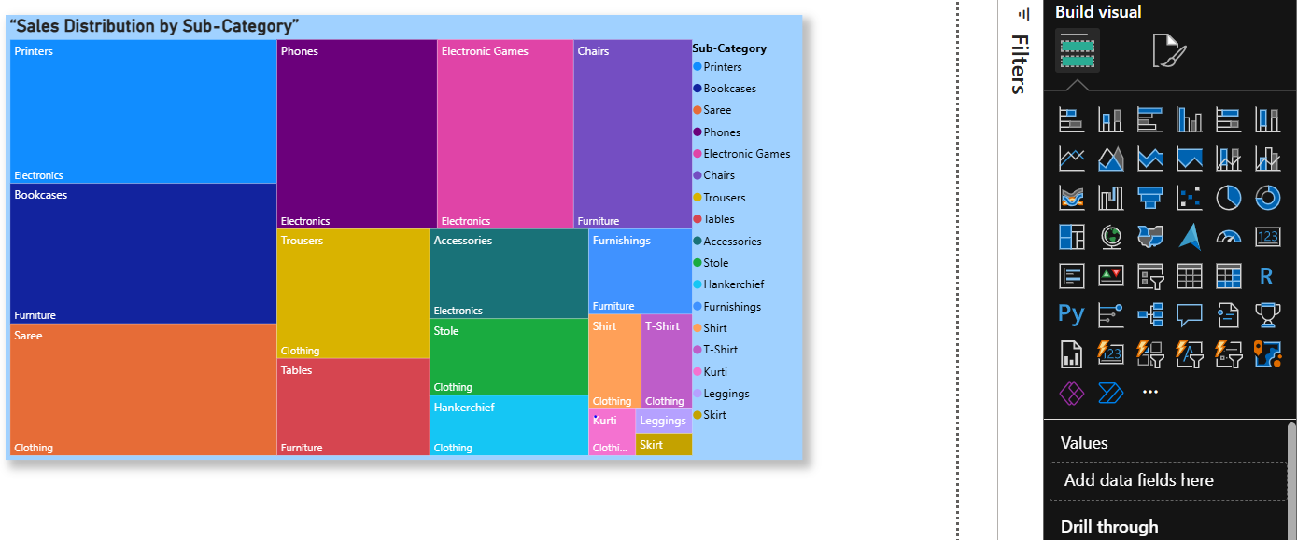

Order Count Analysis by State:
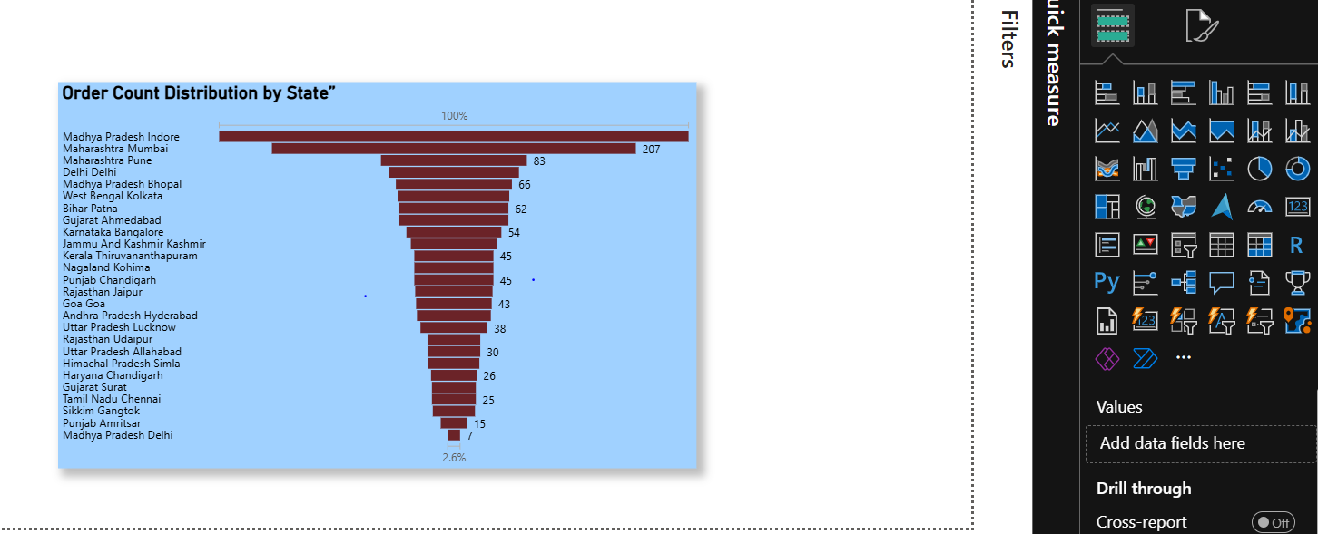

Data visualization
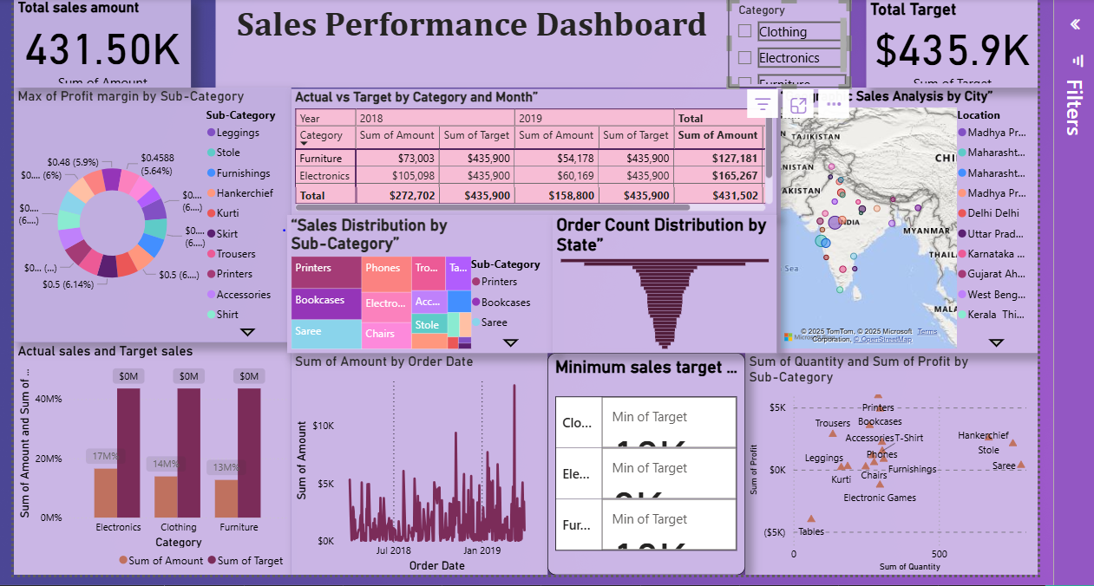

After using slicers
Clothing

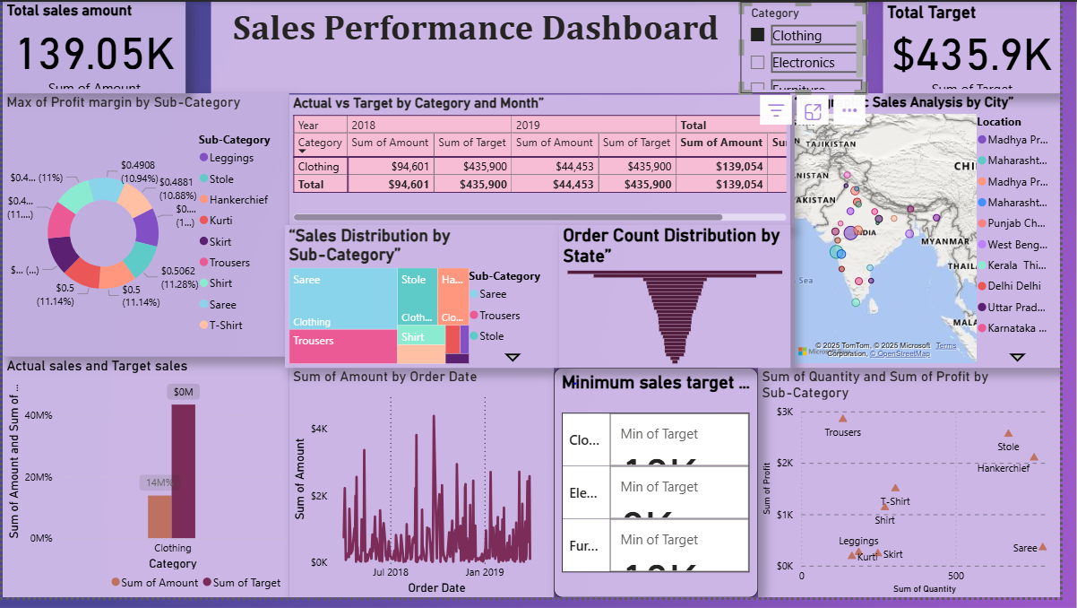
Electronics:
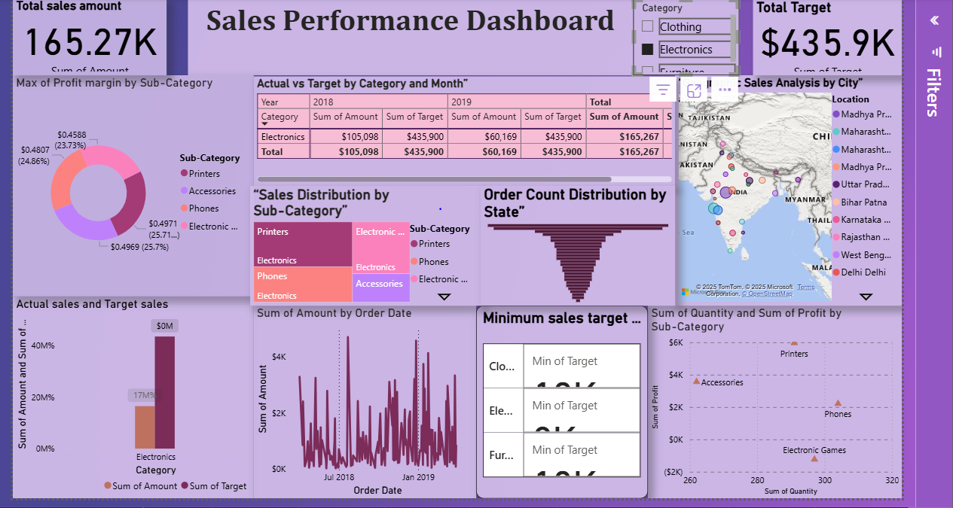
Furniture:
